READ THE USE AND MAINTENANCE HANDBOOK

Check electrical equipment (until the serial number 207003744)
- Check the functionality of the electrical equipment:  - brush motor (the motor starts pushing both brush switch and control levers);  - suction motor (the motor starts pushing the suction switch);  - solenoid valve (it starts pushing both solenoid valve switch and the control levers).  - Check the functionality of the display in the middle of the instrument board:  - switching on, i twill appear a letter indicating the software version, then a red light segment on the low side of the display, then the letter “G” when the setting of the card is for gel batteries and finally the number indicating the charge;  - it indicates the battery charge (4 = full, 0 = empty, brush motor off).  - Check the tightness of the power contacts into the electric box situated on the front side of the machine (behind the metallic cover down the solution tank).  - Check the wear and the functionality of the thermal breakers.  ATTENTION: If lead acid battery is installed, put the jumper as indicated on the picture and take out the other one (switching on the machine, i twill appear the letter “P” instead of the “G”). | 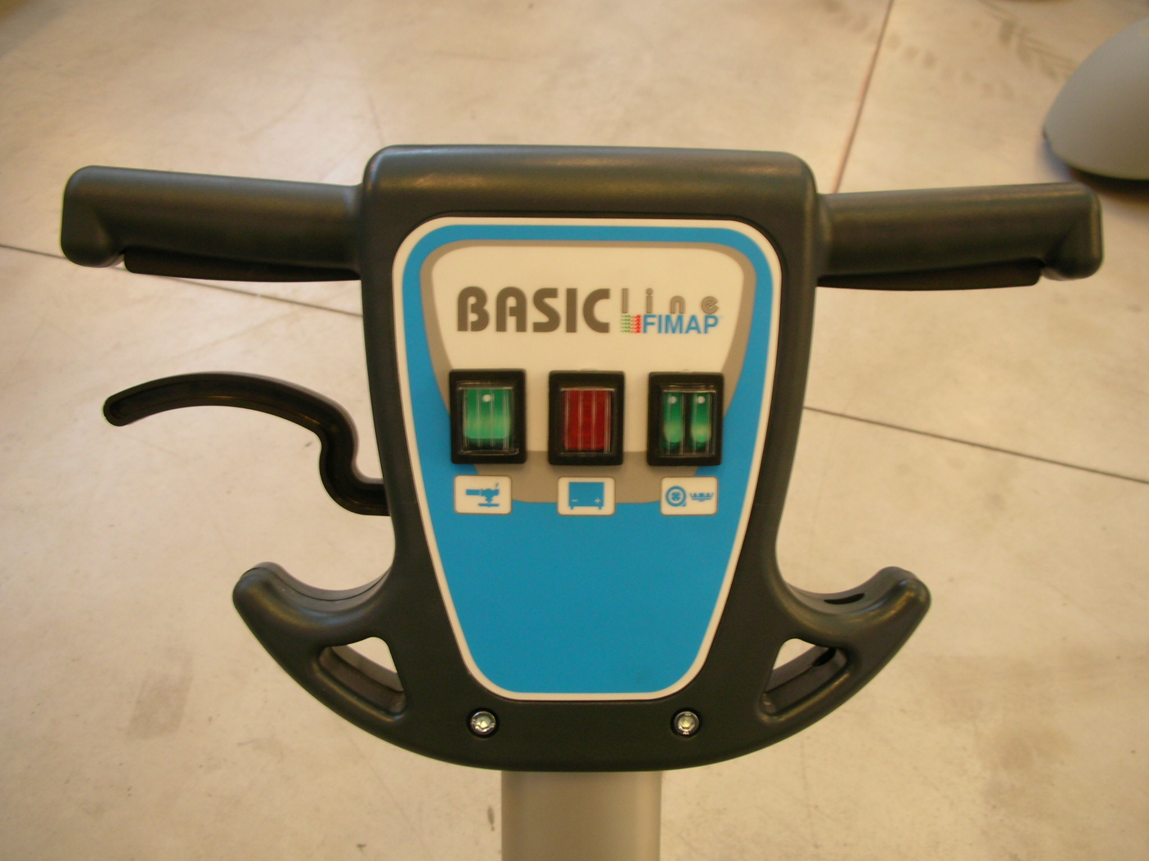  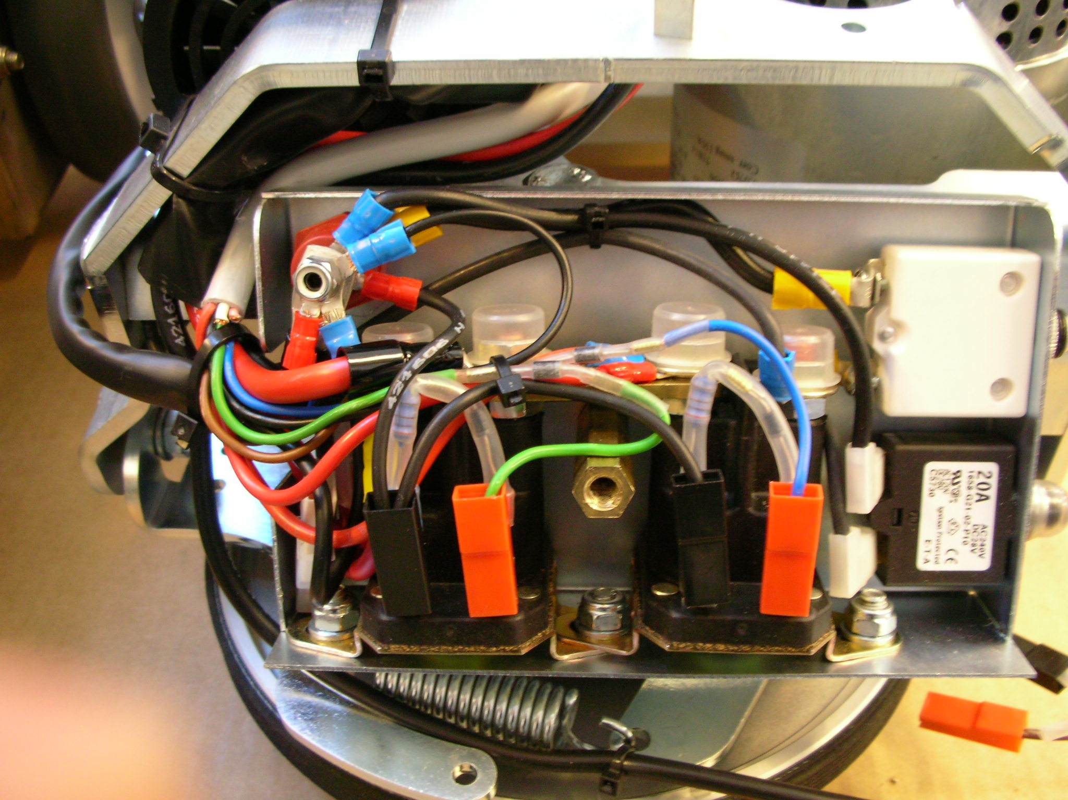

Check electrical equipment (since the serial number 207003745)
- Check the functionality of the electrical equipment:  - brush motor (the motor starts pushing both brush switch and control levers);  - suction motor (the motor starts pushing the suction switch);  - solenoid valve (it starts pushing both solenoid valve switch and the control levers).  - Check the functionality of the display in the middle of the instrument board:  - Turning on the machine, first the letter “G” will appear with card setting on gel batteries and then the number indicating the charge level;  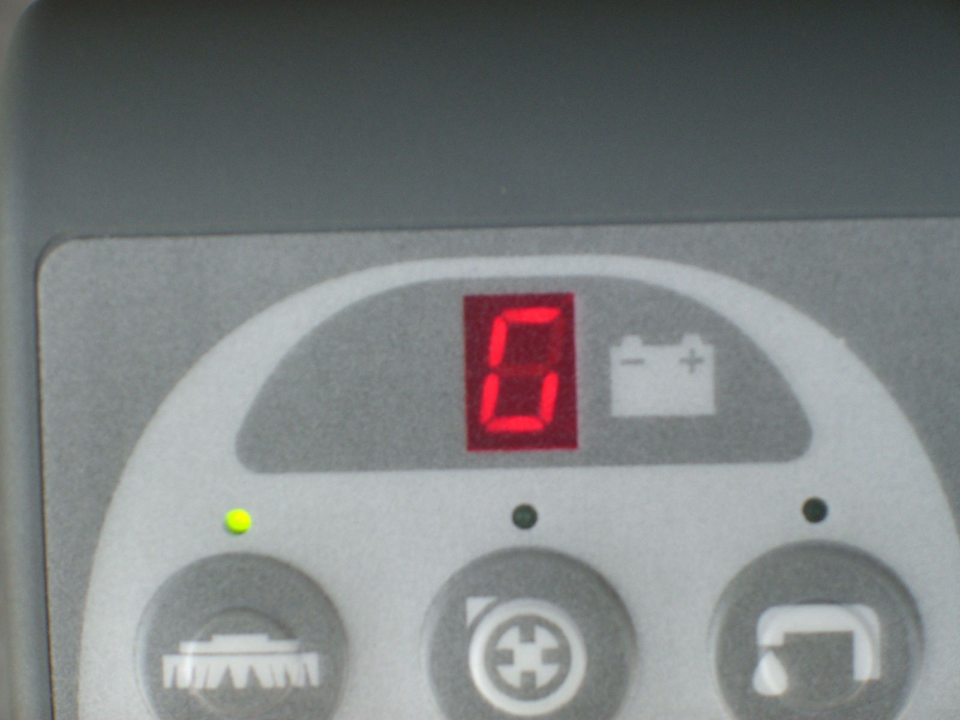  - it indicates the battery charge (4 = full, 0 = empty, brush motor off).  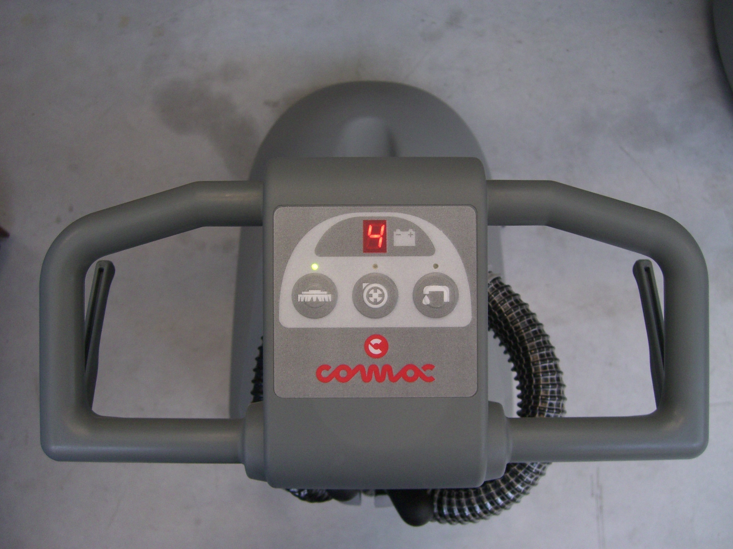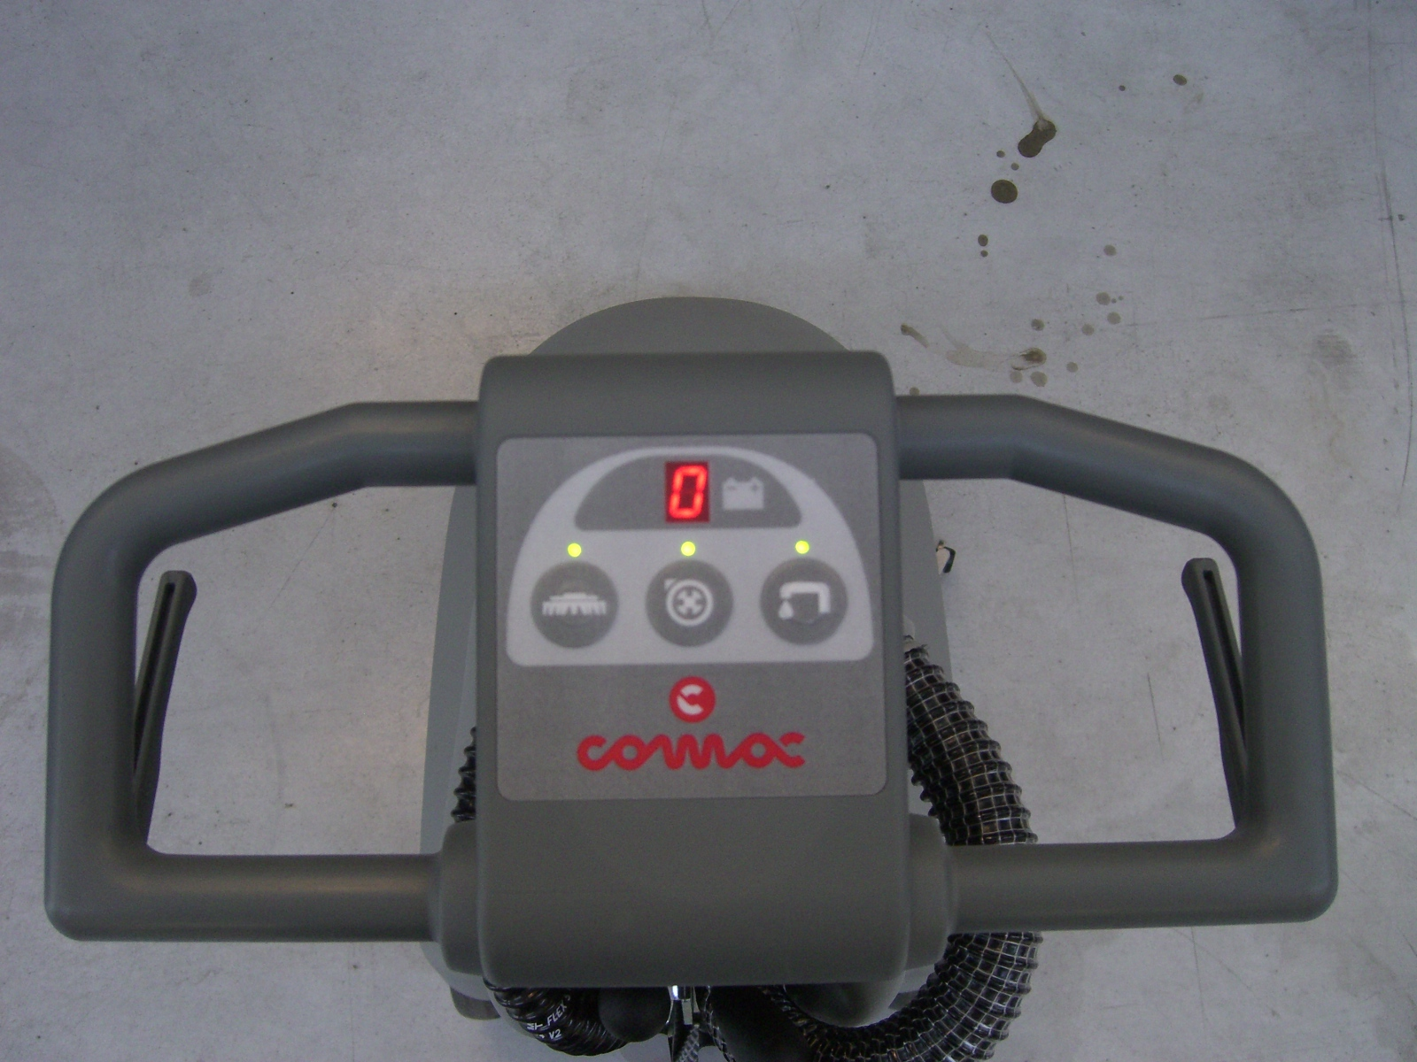  - Check the tightness of the battery contacts and faston cables into the electric box situated on the front side of the machine (behind the ABS cover under the solution tank).  WARNING: If lead acid battery is installed, put the jumper on the pin with “Pb” label as indicated on the picture (switching on the machine, i twill appear the letter “P” instead of the “G”).  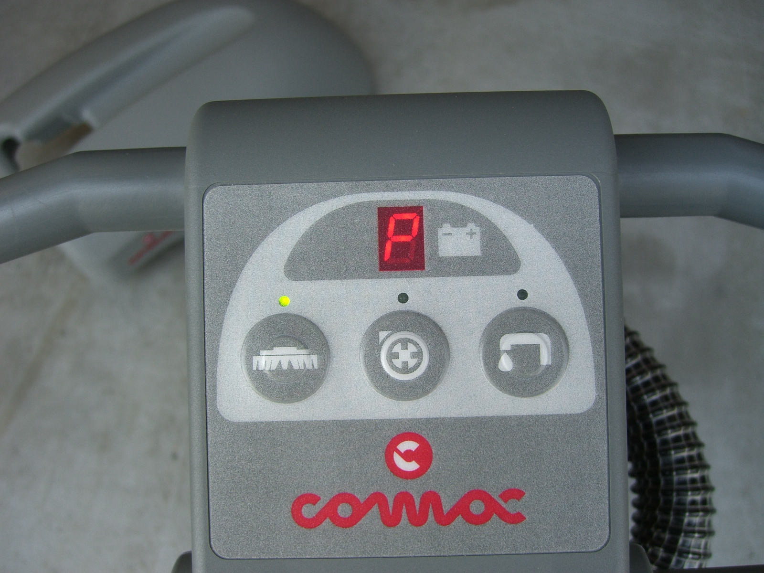  There are two pins nearby with the writing "ECB", in case of breakdown of the control battery, inserting a jumper you can bypass the control and to keep on working up to the discharge of the battery.  WARNING: to use only to diagnose a possible problem of the battery level card. In this condition the battery charge level is not under control and the battery could be damaged by an deep discharge. | 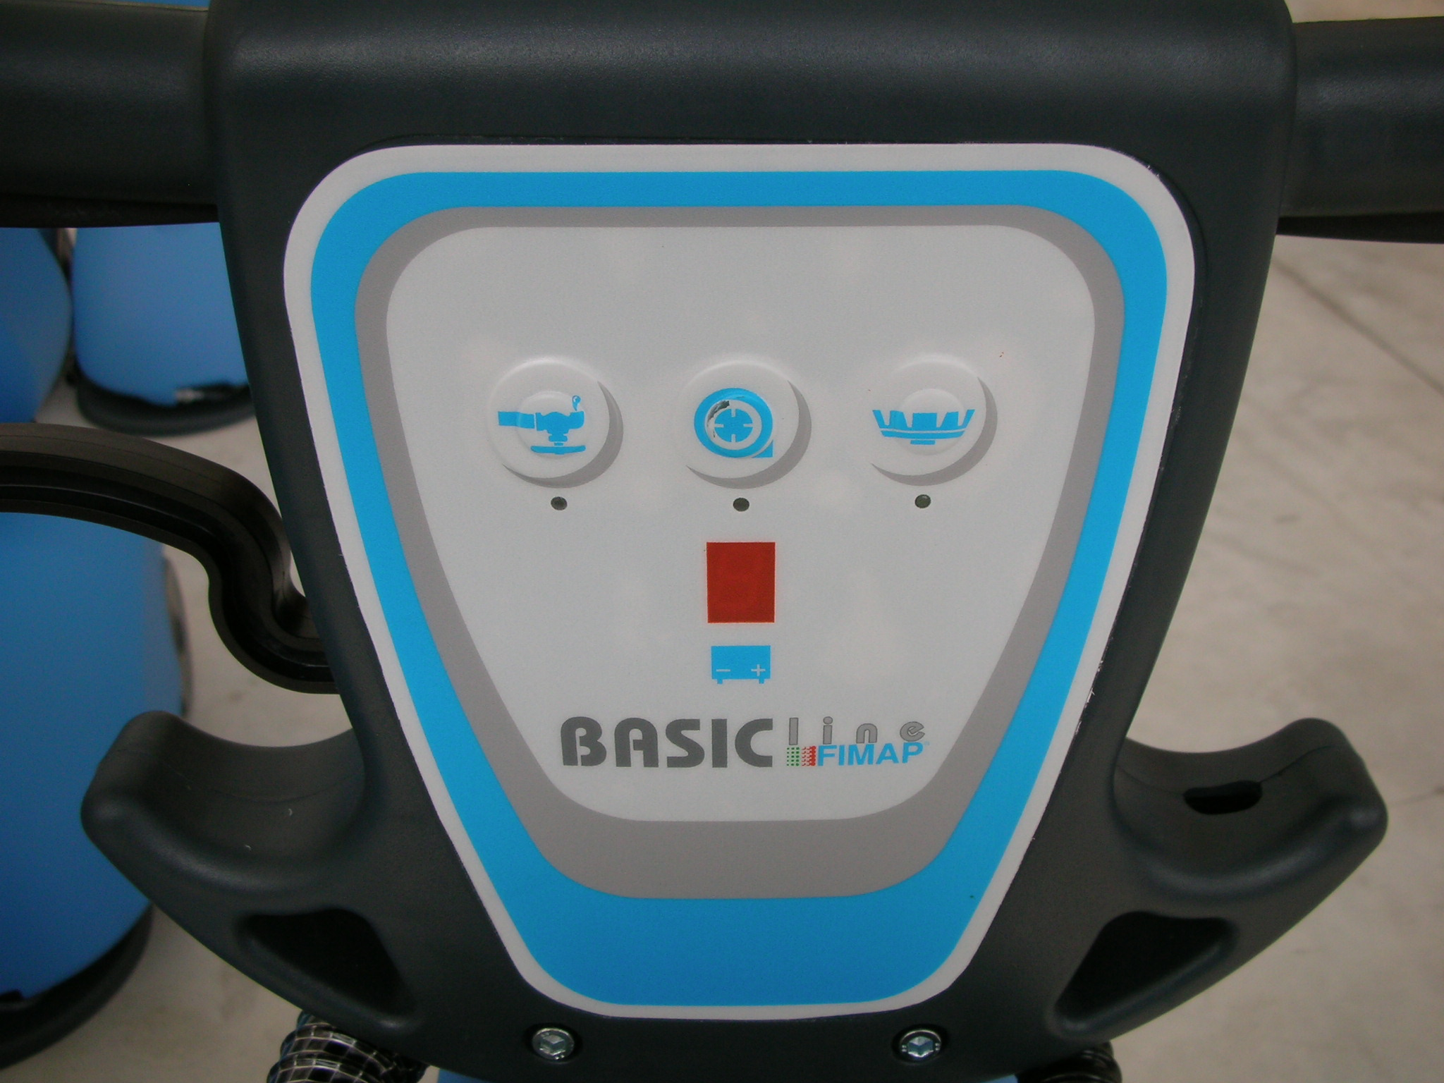  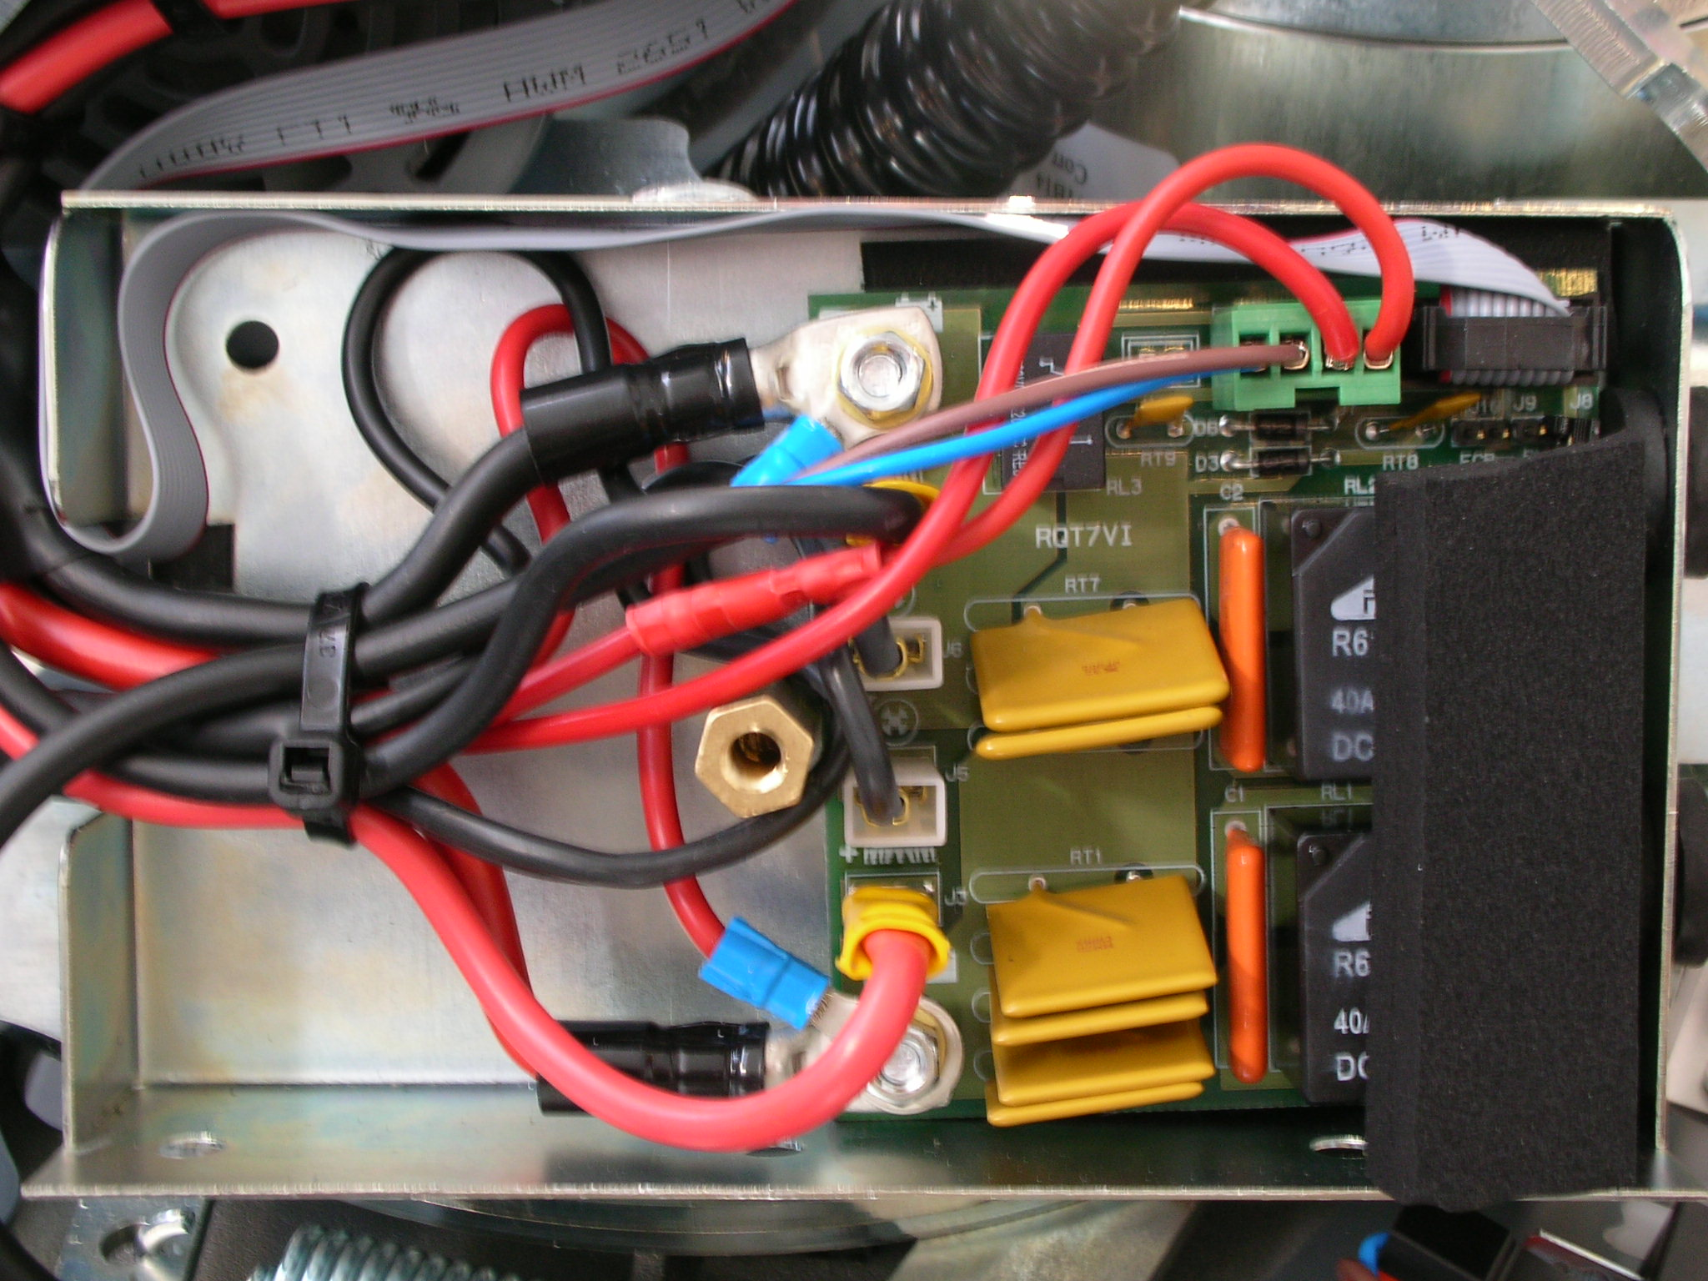  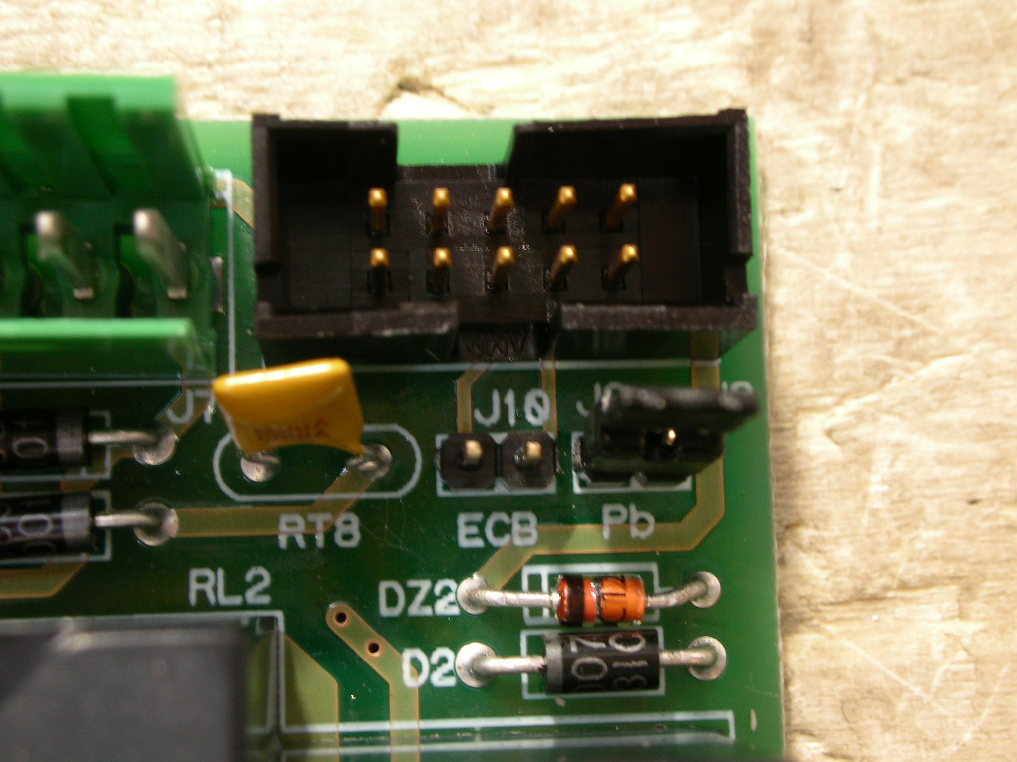

Battery check card inspection
Set a multimeter for voltage readings of maximun 20V. Put the red pin of the tester on the positive pole of the battery and the black pin on the negative pole of the battery to check the threshold of the battery check card:  - Value 4: Vb > 11,6  - Value 3: 11,4 < Vb < 11,6  - Value 2: 11,1 < Vb < 11,4  - Value 1: 10,9 < Vb < 11,1  - Value 0: Vb < 10,9  Any value can have a 0,1 volt of tolerance. The measure of the battery voltage have to be done with the machine in working conditions. To have a more reliable reading let the machine work 10-15 seconds before doing the reading. | 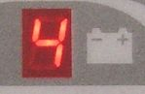  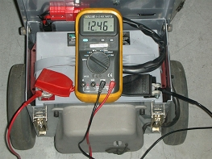

Check the water system
- Full the solution tank and check the tightness of the tubes and gaskets on the cock and solenoid valve.  - Check that the water flow on the floor is uniform and at the cock opening. In any case check the cleaning of the cock.  - Check the quick coupling. | 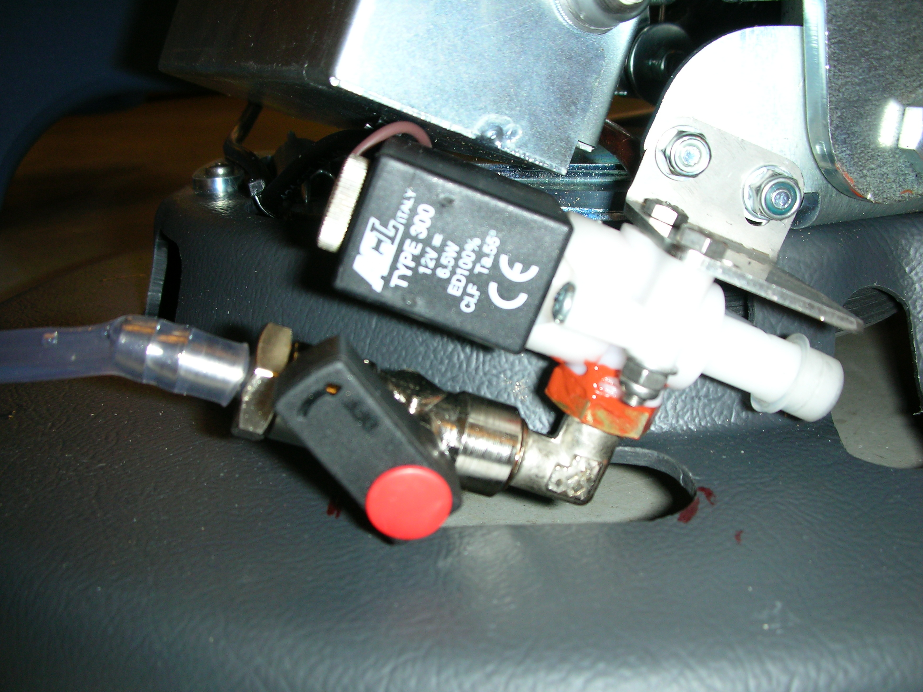  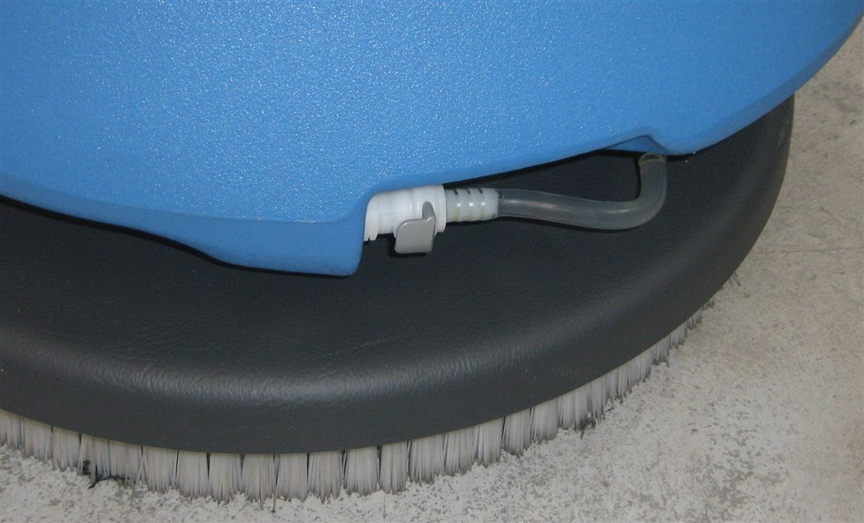

Check the suction system
- Check the cleaning and functionality of the filter with ball.  - Check, if closed, the sealing of the cap on the recovery tank, verifying the good wear of the gaskets. | 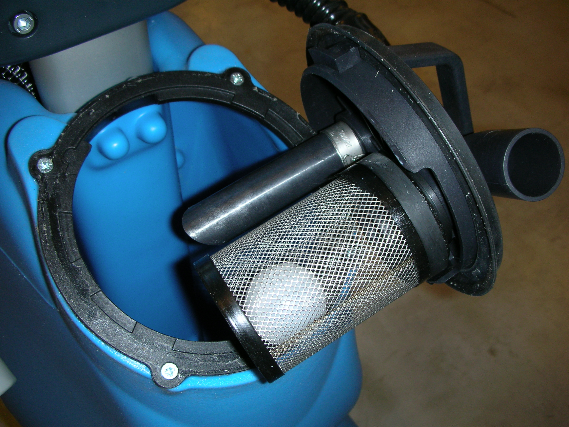
- Check the right position and sealing of the muffs on the recovery tank cap. | 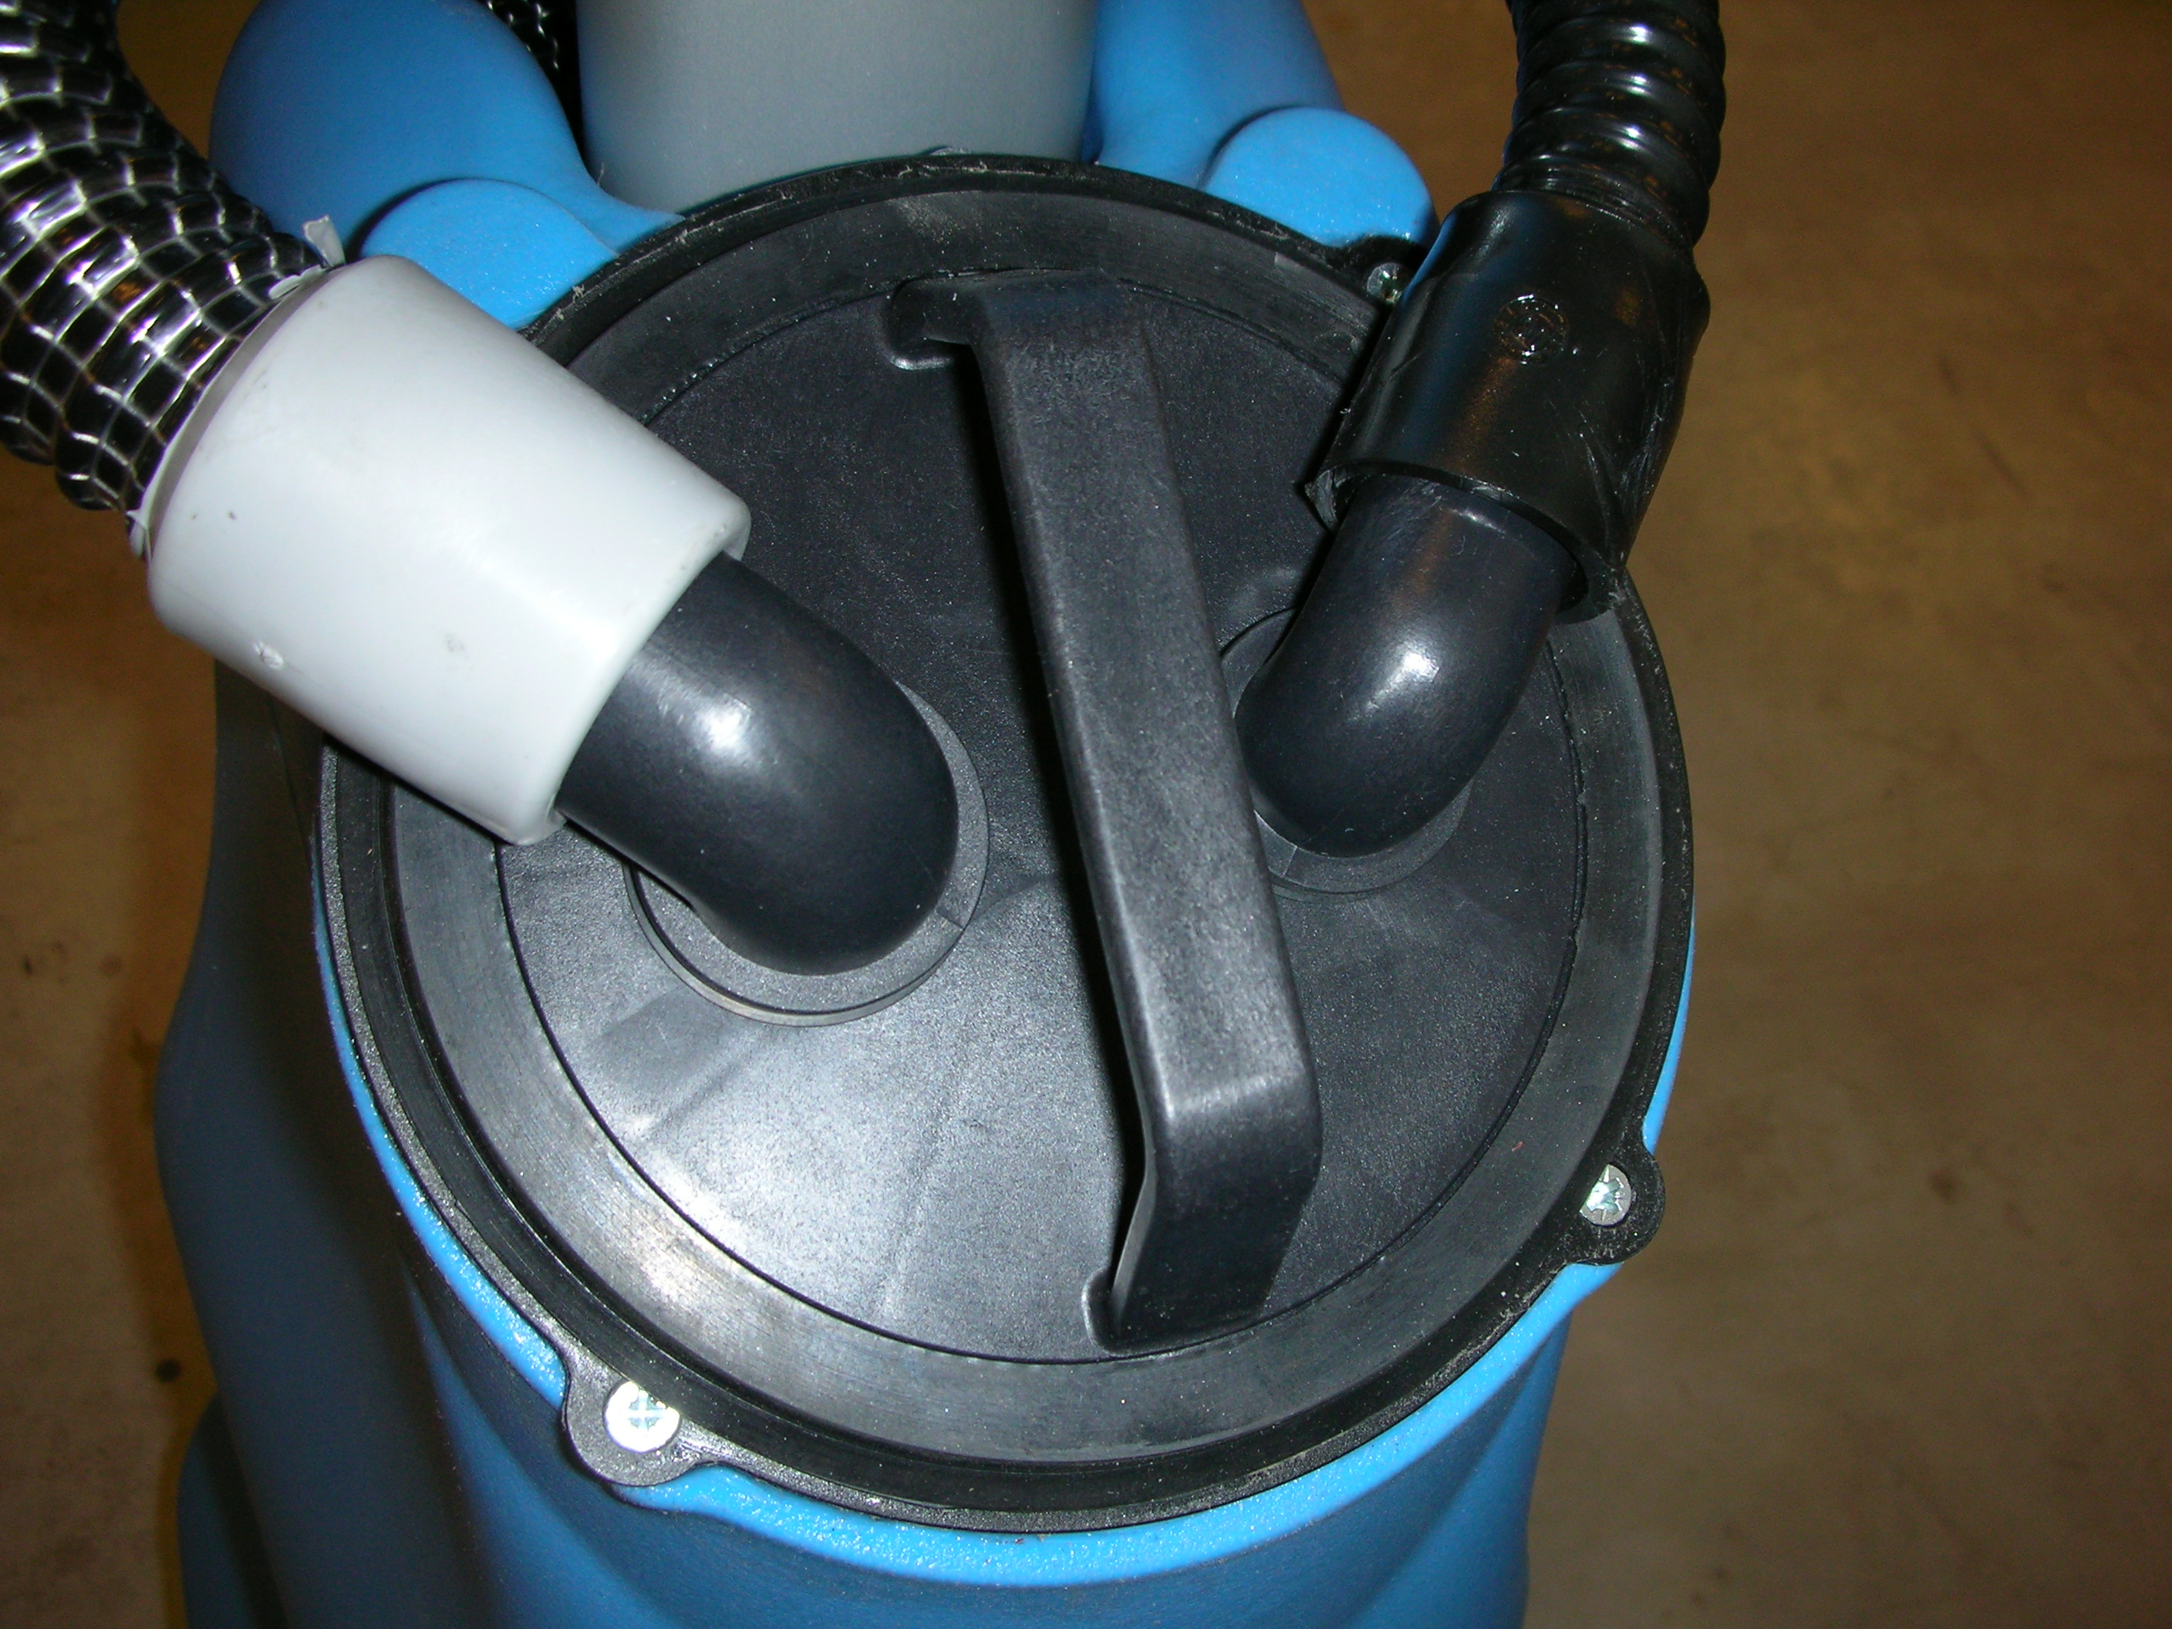
- Check the wear of the squeegee rubber and the right closing of the knobs.  - Check the closing of the knobs of the squeegee blade.  - Adjust the side squeegee wheels with the screw threads with the blade and the central wheel all low. | 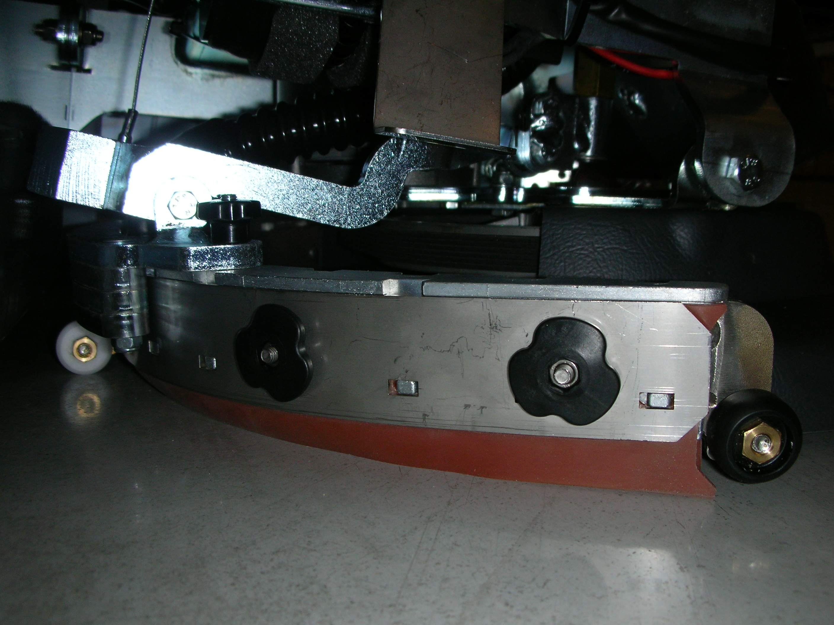
- Screw the lock nut so that there is clearance between the arm and the squeegee support. Unscrew lightly if the squeegee lifts up when it turns. | 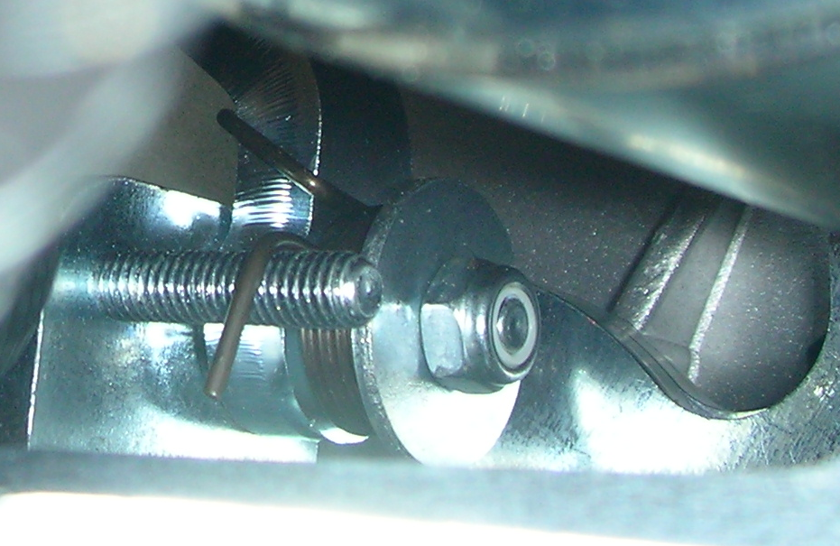
- Adjust the rope of squeegee control so that the threaded is out of 1-2 mm. from the squeegee side and 5-6 mm. from the knob side. | 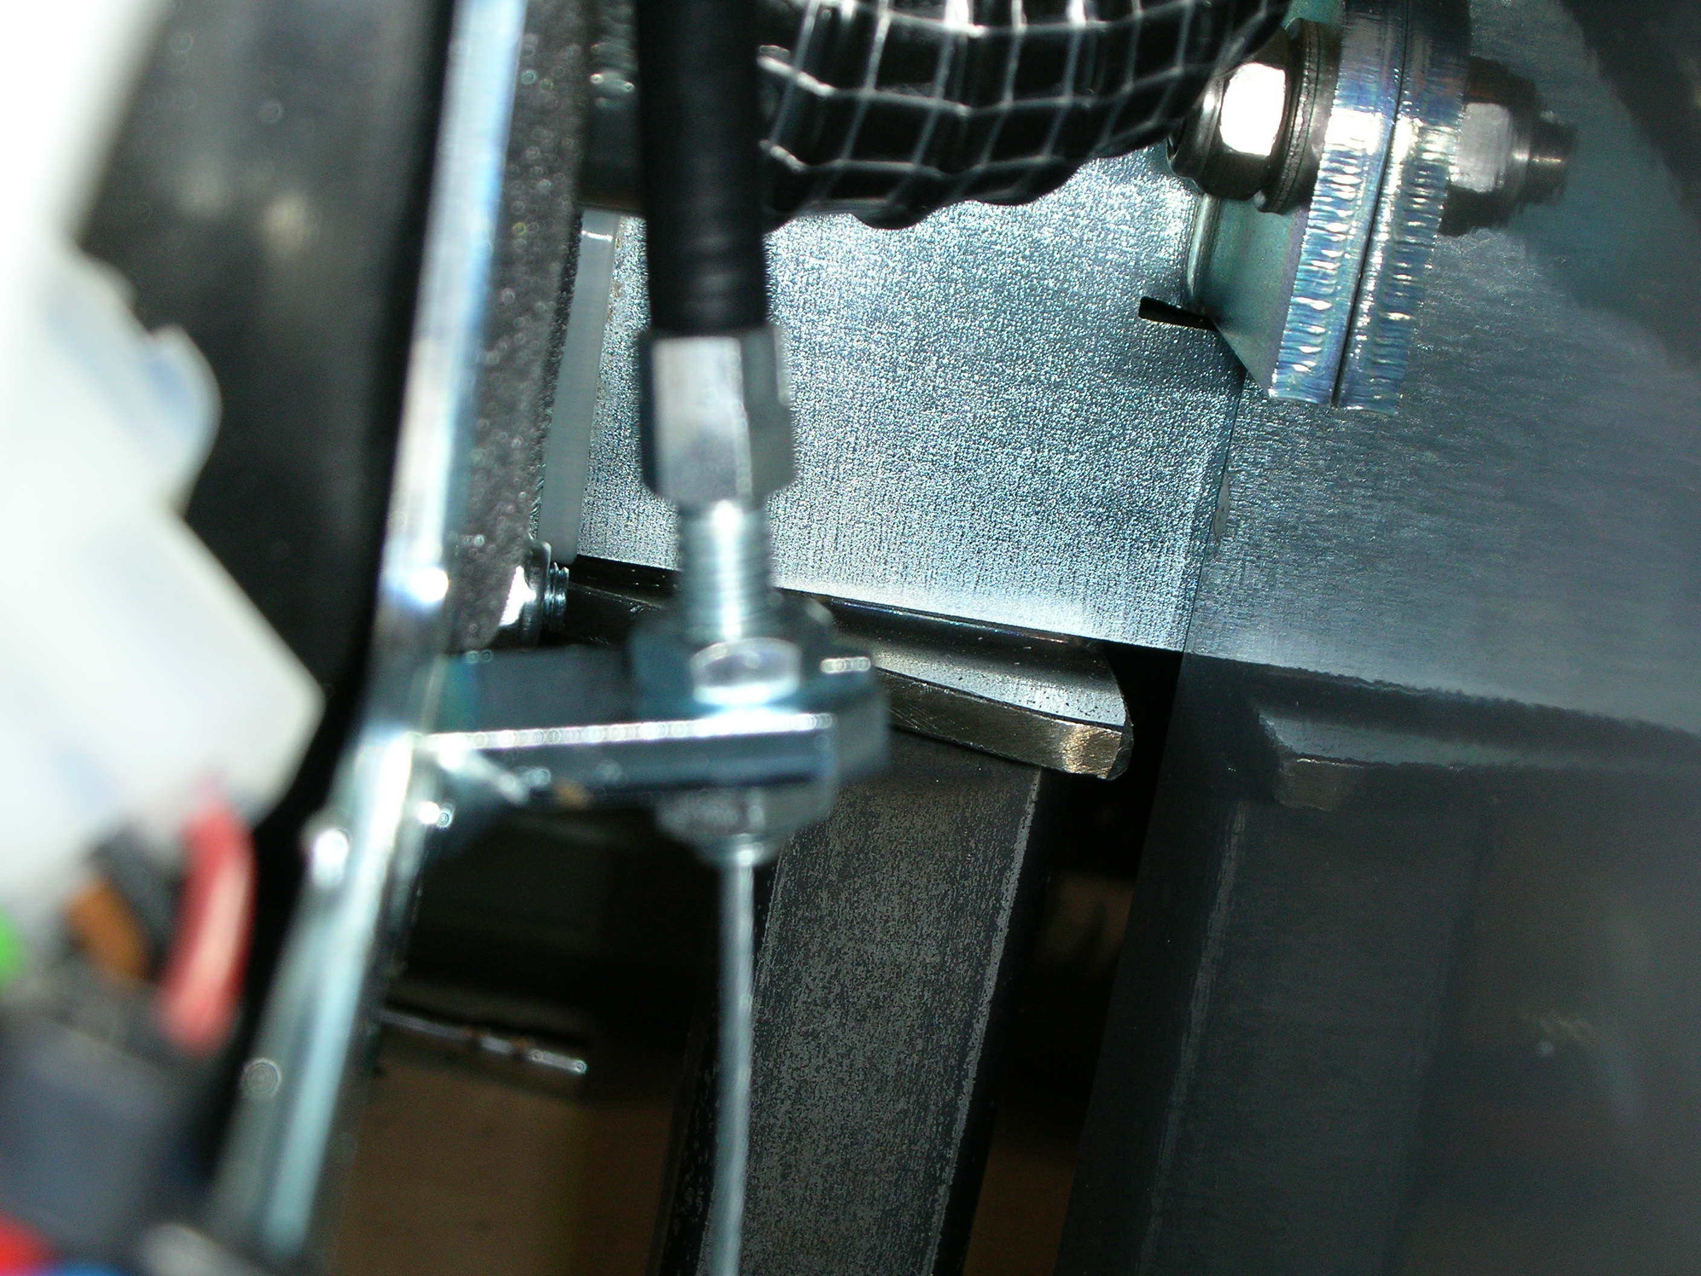

Check brush base
- Check that the brush base support on the right side is free to move inside the hole of the frame arm. This allows the brush base to adjust itself on the floor. If, it is necessary, unscrew lightly the lock nut. | 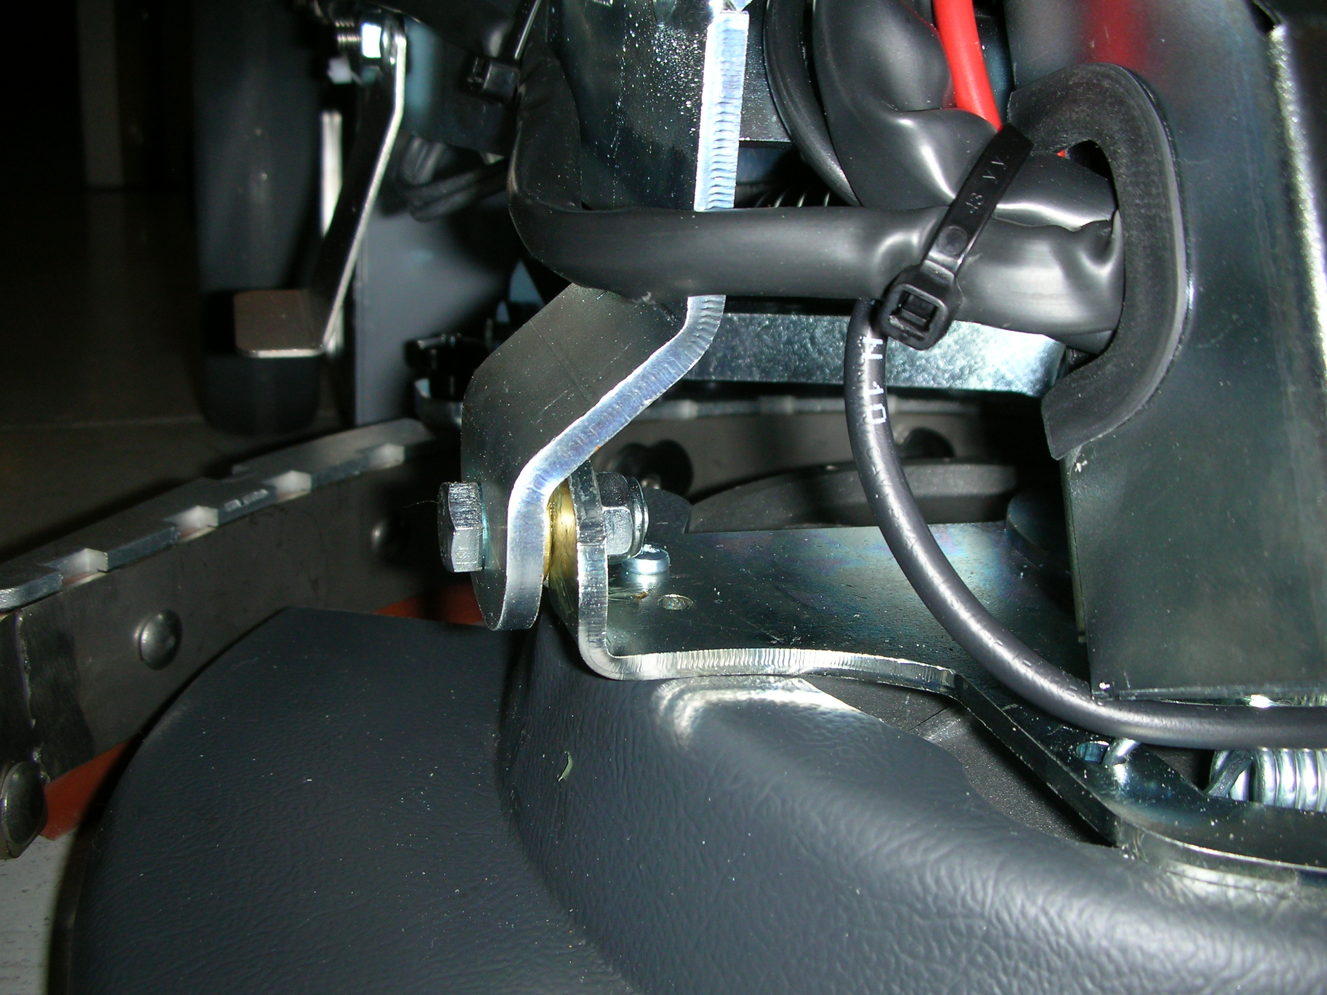

Check charger
- Check that the charger makes the initial test :  - green led with two blinkings : charger setted for gel or agm batteries;  - red led with two blinkings : charger setted for lead acid batteries.  - Check the functionality of the led of the charger during the charging time :  - fix red led : first time during normal charging;  - fix yellow led : second time during normal charging;  - fix green led : ending of the charging or maintenance time.  - In the case of the blinking red led, it could happen the following problems:  - before the charging time :  - wrong battery : check the type of the battery;  - battery not connected : check the connection;  - problem on the charger : replace it;  - after or during the charging time :  - battery defected : check and eventually replace it;  - disconnect and reconnect the charger;  - replace the charger. | 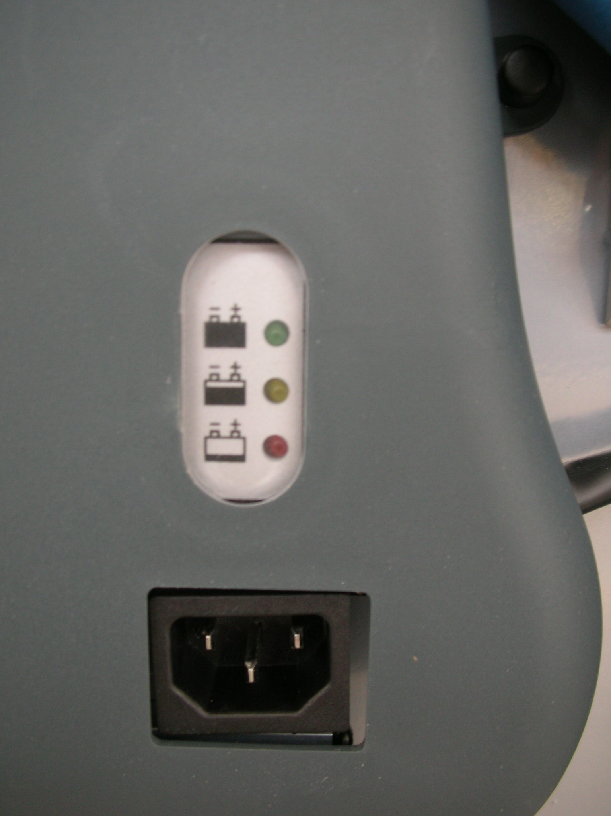

Final test
Check all functions: cleaning, drying.

